STUDENT MANAGEMENT SYSTEM

# FUNDAMENTALS OF PROGRAMMING ASSIGNMENT 1

## **Student Name – Pranidhi Peiris**

## **Student Id - 1853364**

TABLE OF CONTENT

# Pseudocode

# Flowchart

# Control Flow

# Conditional Statement

# Lists

# Loops

ChatGPT Interaction Documentation

# 1.Pseudocode

**START PROGRAM**

**DEFINE constants:**

**HD_THRESHOLD = 85**

**D_THRESHOLD = 75**

**C_THRESHOLD = 65**

**P_THRESHOLD = 50**

**INITIALIZE empty list: students = []**

**DEFINE FUNCTION categorise_grade(mark):**

**IF mark >= HD_THRESHOLD:**

**RETURN "HD (High Distinction)"**

**ELSE IF mark >= D_THRESHOLD:**

**RETURN "D (Distinction)"**

**ELSE IF mark >= C_THRESHOLD:**

**RETURN "C (Credit)"**

**ELSE IF mark >= P_THRESHOLD:**

**RETURN "P (Pass)"**

**ELSE:**

**RETURN "F (Fail)"**

**DEFINE FUNCTION add_student():**

**PROMPT user for name**

**PROMPT user for mark (as string)**

**IF mark is numeric:**

**CONVERT mark to integer**

**IF mark is between 0 and 100:**

**grade = categorise_grade(mark)**

**APPEND {"name": name, "mark": mark, "grade": grade} to students list**

**DISPLAY success message**

**ELSE:**

**DISPLAY "Mark must be between 0 and 100"**

**ELSE:**

**DISPLAY "Invalid input"**

**DEFINE FUNCTION remove_student():**

**PROMPT user for name**

**FOR each student in students:**

**IF student name matches (case-insensitive):**

**REMOVE student from students list**

**DISPLAY "Removed successfully"**

**RETURN**

**DISPLAY "Student not found"**

**DEFINE FUNCTION update_student():**

**PROMPT user for name**

**FOR each student in students:**

**IF student name matches (case-insensitive):**

**PROMPT for new name (optional)**

**PROMPT for new mark (optional)**

**IF new mark provided:**

**IF new mark is numeric:**

**CONVERT to integer**

**IF mark is between 0 and 100:**

**UPDATE student mark**

**RECALCULATE grade**

**ELSE:**

**DISPLAY "Mark must be between 0 and 100"**

**RETURN**

**ELSE:**

**DISPLAY "Invalid mark"**

**RETURN**

**IF new name provided:**

**UPDATE student name**

**DISPLAY "Updated successfully"**

**RETURN**

**DISPLAY "Student not found"**

**DEFINE FUNCTION view_students():**

**IF students list is empty:**

**DISPLAY "No records"**

**RETURN**

**FOR each student in students:**

**DISPLAY student name, mark, and grade**

**LOOP FOREVER:**

**DISPLAY menu options (Add, View, Update, Remove, Exit)**

**PROMPT user for choice**

**IF choice == "1":**

**CALL add_student()**

**ELSE IF choice == "2":**

**CALL view_students()**

**ELSE IF choice == "3":**

**CALL update_student()**

**ELSE IF choice == "4":**

**CALL remove_student()**

**ELSE IF choice == "5" OR input is empty:**

**DISPLAY "Goodbye!"**

**BREAK loop**

**ELSE:**

**DISPLAY "Invalid choice"**

**END PROGRAM**

# 2.Flowchart

# 3. Control Flow

## Prompt to ChatGPT

ChatGPT Response  
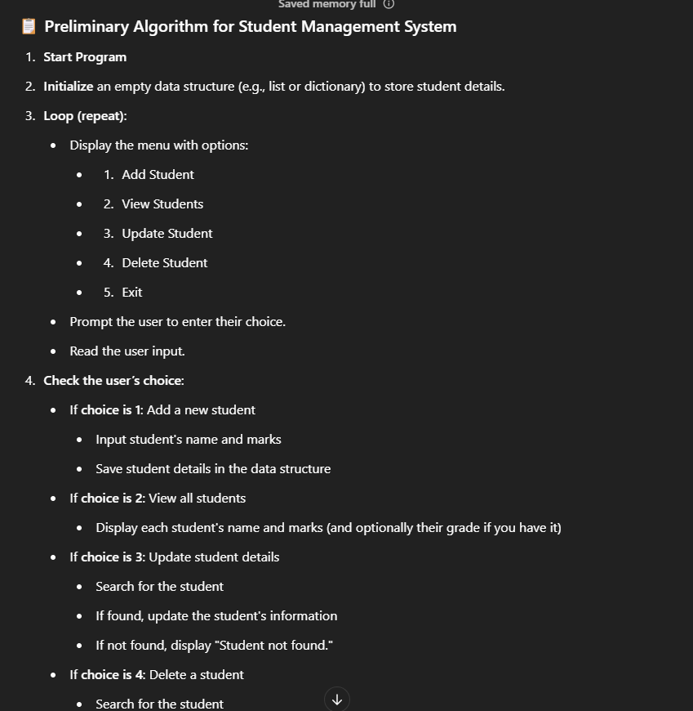

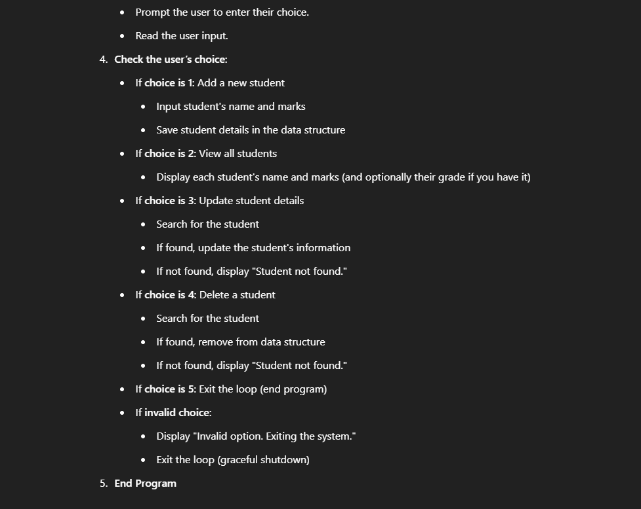

# 4. Conditional Statements

## Prompt to ChatGPT

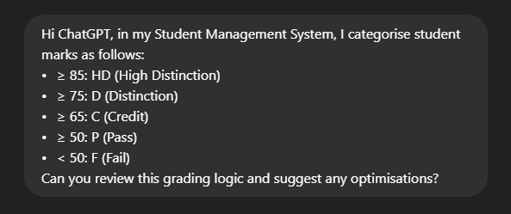ChatGPT Response  
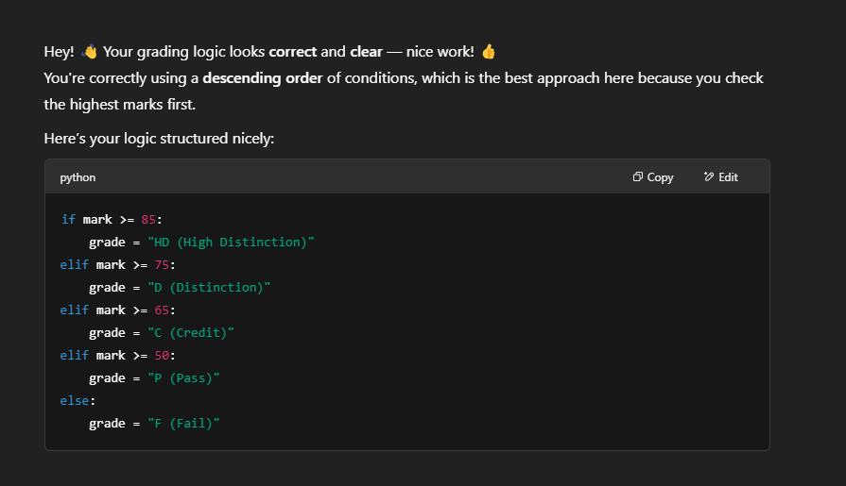

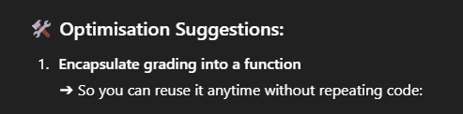

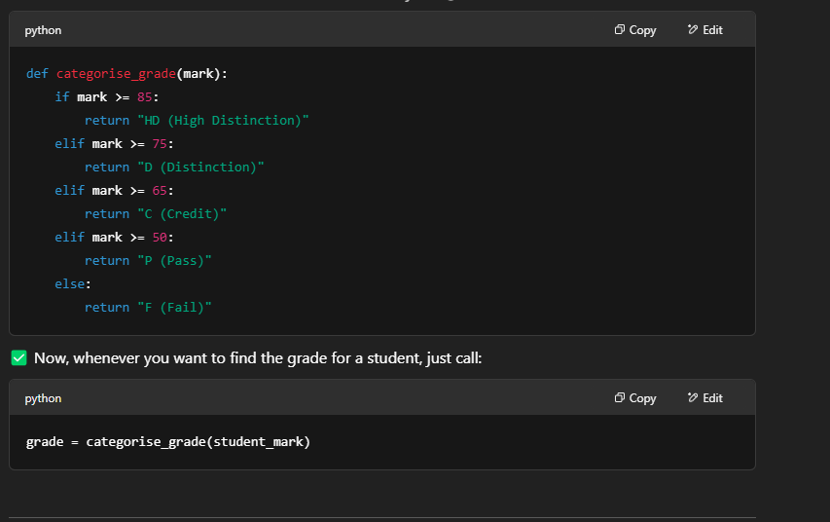

# 5. Lists

## Prompt to ChatGPT

ChatGPT Response

# 6. Loops

## Prompt to ChatGPT

ChatGPT Response  
